 | 
PROJECT REPORT
Voice-Based Concept Understanding Analyser (VBCUA)
An AI-powered application to evaluate spoken conceptual explanations
Team ID: Individual Project
Project Name: VBCUA – Voice-Based Concept Understanding Analyser
Date: 07 July 2026
Status: Built and Functionally Verified

Table of Contents
1. Abstract
2. Introduction
3. Objectives
4. Existing System vs. Proposed System
5. System Requirements
6. System Architecture
7. Technology Stack
8. Implementation Details
9. Testing & Verification
10. Advantages and Limitations
11. Conclusion
12. Future Scope
13. References

1. Abstract
Traditional academic and hiring assessments emphasize written answers, leaving verbal communication — a critical real-world skill — largely unevaluated. VBCUA (Voice-Based Concept Understanding Analyser) addresses this gap by combining speech-to-text transcription, semantic similarity scoring, audio-based fluency analysis, AI-generated feedback, and automated PDF reporting into a single web application. A learner selects a topic, records a spoken explanation, and receives an objective, two-dimensional evaluation of both conceptual accuracy and delivery quality within seconds. This report documents the problem, design, implementation, and verification of VBCUA, which was built end-to-end using OpenAI Whisper, Sentence-BERT, Librosa, Google Gemini, and Streamlit, and validated with an automated test suite of 17 passing tests.

2. Introduction
Explaining a concept clearly out loud requires more than knowing the material — it requires organizing thoughts on the fly, speaking fluently, and adapting to a listener in real time. This skill is assessed in vivas, interviews, presentations, and teaching, yet learners rarely get consistent, objective feedback on it, since manually listening to and grading spoken answers does not scale for instructors, and self-assessment is inherently unreliable.

2.1 Problem Statement
Students preparing for oral exams, instructors evaluating many spoken submissions, and job seekers rehearsing interview answers all share the same underlying problem: there is no fast, objective way to check whether a spoken explanation is both conceptually correct and clearly delivered. VBCUA was built to close that gap using automated speech and language AI.

3. Objectives
- Convert a learner's spoken explanation into text using OpenAI Whisper.
- Score conceptual accuracy by comparing the transcript to a reference explanation using Sentence-BERT.
- Analyze spoken delivery — pace, pauses, and filler words — using Librosa.
- Combine both signals into a single, weighted overall score and grade.
- Generate natural-language feedback using Google Gemini, with an offline fallback.
- Persist every evaluation and expose history/trends through a dashboard.
- Produce a professional, downloadable PDF report for each evaluation.

4. Existing System vs. Proposed System

4.1 Existing Approach
Spoken-explanation assessment today is almost entirely manual: instructors listen to students one at a time, or peers give informal, inconsistent feedback. Written quizzes and MCQs, the typical automated alternative, do not test verbal articulation at all, leaving a measurable gap between what is tested and what is actually needed in vivas, interviews, and presentations.

4.2 Proposed System — VBCUA
VBCUA automates the entire evaluation loop. A learner uploads a recording; the system transcribes it, scores it against a reference explanation and against fluency benchmarks, generates written feedback, and returns a report — all within roughly 30 seconds for a short recording. This turns an otherwise manual, unscalable process into an on-demand, self-serve practice tool.

5. System Requirements
A condensed summary of the functional requirements driving the build (see the separate Solution Requirements document for the full functional and non-functional requirement list):
Requirement | Description | Priority
Speech-to-Text | Transcribe uploaded audio using Whisper. | High
Semantic Scoring | Compare transcript to reference explanation via Sentence-BERT. | High
Fluency Scoring | Detect pace, pauses, and filler words via Librosa. | High
AI Feedback | Generate feedback via Gemini, with rule-based fallback. | High
PDF Reporting | Produce a downloadable evaluation report via ReportLab. | High
Dashboard | Show evaluation history and score trends. | Medium
Persistence | Store evaluations via SQLAlchemy (SQLite/PostgreSQL). | High
Authentication | Not required for the current single-user version. | Low

6. System Architecture
VBCUA follows a linear pipeline architecture: the learner's audio flows through transcription, scoring, feedback generation, and reporting, with two data stores supporting the process — a static topic/reference-explanation store and a persistent evaluations database. The diagram below (from the project's Data Flow Diagram) illustrates this flow.
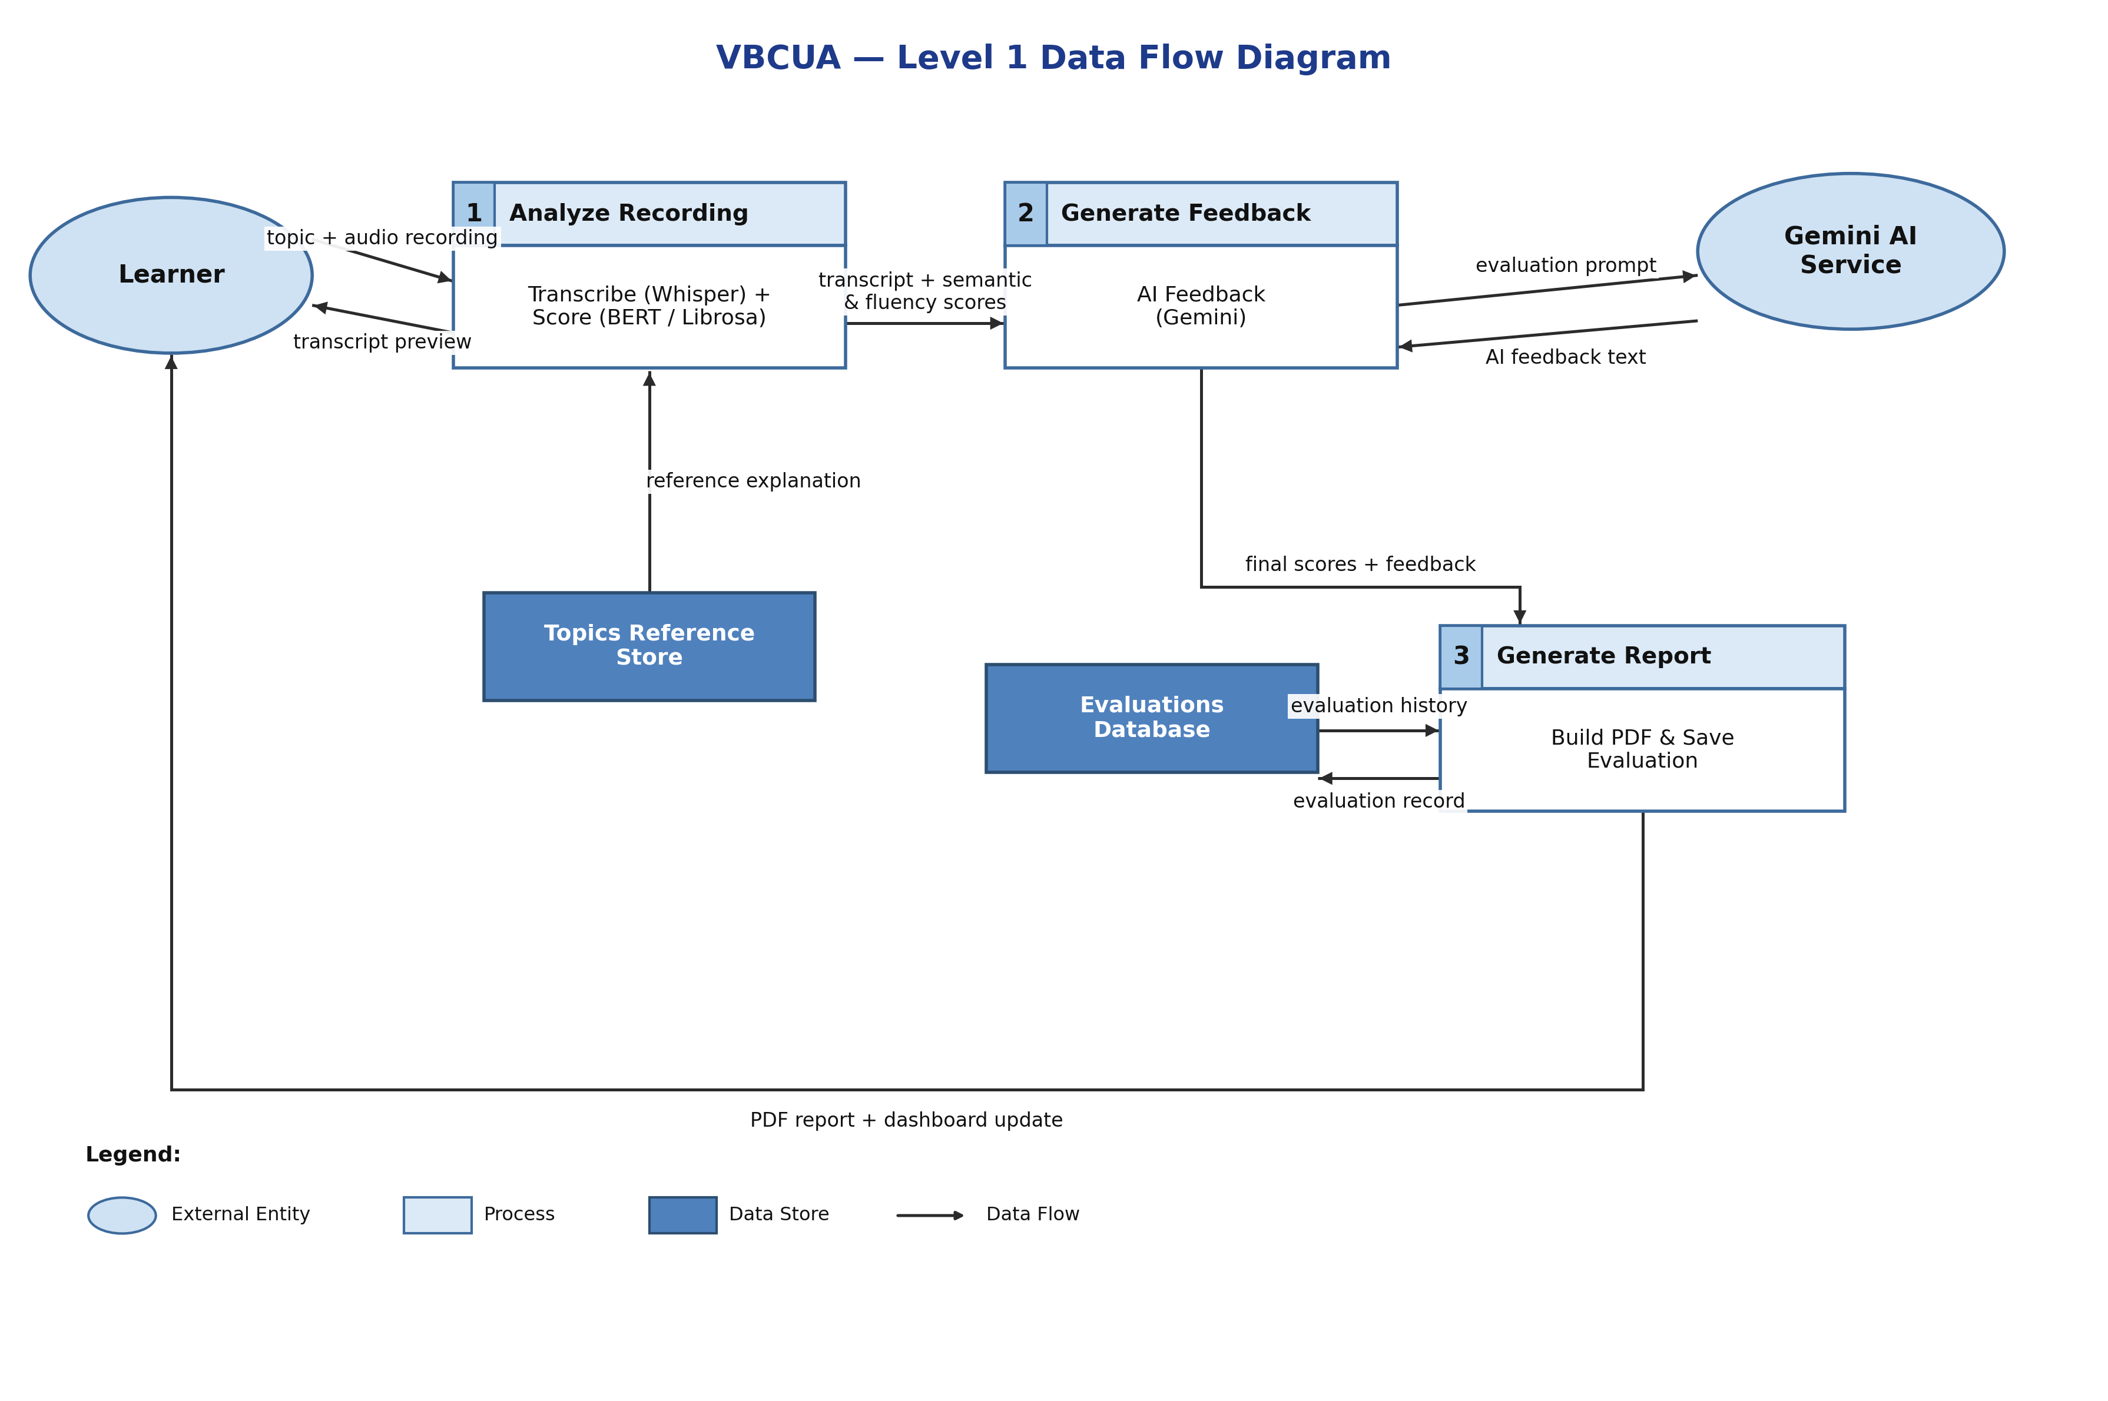

6.1 Project Structure
- app.py — Streamlit UI entry point, orchestrates the full pipeline.
- config.py — centralized configuration (paths, model names, weights, thresholds).
- src/transcription.py — Whisper-based speech-to-text.
- src/semantic_analysis.py — Sentence-BERT cosine similarity scoring.
- src/audio_analysis.py — pause detection, filler detection, WPM, fluency score, waveform image.
- src/scoring.py — weighted overall score and grade banding.
- src/feedback.py — Gemini feedback generation with rule-based fallback.
- src/pdf_report.py — ReportLab PDF report builder.
- src/database.py — SQLAlchemy models and persistence functions.
- data/topics.py — sample topics and reference explanations.
- tests/ — automated Pytest suite (17 tests).

7. Technology Stack
Layer | Technology
Frontend | Streamlit
Backend | Python 3.12
Speech-to-Text | OpenAI Whisper (default model: base)
Semantic Analysis | Sentence-BERT (all-MiniLM-L6-v2)
Audio Processing | Librosa + SoundFile
AI Feedback | Google Gemini API (gemini-1.5-flash), rule-based fallback
Database | SQLAlchemy ORM — SQLite (default) or PostgreSQL
PDF Reporting | ReportLab
Testing | Pytest + pytest-mock

8. Implementation Details

8.1 Transcription
Whisper is loaded once and cached; audio is transcribed to plain text plus timed segments, which downstream modules use for scoring.

8.2 Semantic Scoring
The transcript and the topic's reference explanation are embedded with Sentence-BERT, and their cosine similarity is rescaled to a 0–100 semantic score.

8.3 Fluency Scoring
Librosa detects silent gaps (pauses) and, combined with word count and filler-word detection (regex word-boundary matching), produces a weighted fluency score: 40% speaking rate, 30% pause quality, 30% filler-word rate.

8.4 Overall Scoring
Overall Score = (Semantic × 0.6) + (Fluency × 0.4) by default (configurable), mapped to grade bands: ≥85 Excellent, ≥70 Good, ≥50 Fair, below 50 Needs Improvement.

8.5 AI Feedback & Reporting
Gemini generates qualitative feedback from the transcript, reference, and scores; if unavailable, a deterministic rule-based generator produces equivalent feedback so the pipeline never breaks. ReportLab then assembles a PDF combining the scores, waveform, transcript, and feedback, and SQLAlchemy persists the full record.

9. Testing & Verification
The project was verified with an automated Pytest suite plus a live end-to-end run:
- test_scoring.py — weighted averaging, default weights, grade banding, zero-weight fallback (4 tests).
- test_semantic_analysis.py — cosine similarity edge cases and mocked model scoring (5 tests).
- test_audio_analysis.py — filler-word detection, WPM calculation, fluency scoring (5 tests).
- test_database.py — save/retrieve, topic filtering, serialization (3 tests).
Result: 17 / 17 tests passing. All heavy dependencies (torch, Whisper, Sentence-Transformers, Librosa) were installed and verified; the Streamlit server was launched and confirmed to serve correctly (HTTP 200), and PDF generation was confirmed to produce a valid file.

10. Advantages and Limitations

10.1 Advantages
- Fully automated — no instructor time required per attempt.
- Dual evaluation of both what is said and how it is said.
- Works offline for feedback generation via the rule-based fallback.
- Modular codebase that is easy to test, extend, or swap components in.

10.2 Limitations
- Single-user design; no authentication or multi-user roles yet.
- Reference explanations are limited to a fixed set of five sample topics.
- English-only transcription and scoring in the current version.
- No real-time microphone capture; audio must be uploaded as a file.

11. Conclusion
VBCUA successfully demonstrates that speech-to-text, semantic similarity, and audio fluency analysis can be combined into a practical, automated tool for evaluating spoken conceptual understanding. The system was built, tested (17/17 passing tests), and run end-to-end successfully, confirming that it meets its core objective: giving learners fast, objective, two-dimensional feedback on their spoken explanations without requiring an instructor's time.

12. Future Scope
- Real-time in-browser microphone recording.
- Multilingual transcription and semantic comparison.
- Emotion/tone detection from voice.
- User authentication and role-based access (Learner / Instructor / Admin).
- Richer analytics dashboard with topic-level and cohort breakdowns.
- LMS integration (e.g., Moodle, Canvas) for classroom deployment.
- One-click cloud deployment (Docker + hosted PostgreSQL).

13. References
- OpenAI Whisper — https://github.com/openai/whisper
- Sentence-Transformers — https://www.sbert.net
- Librosa — https://librosa.org
- Google Gemini API — https://ai.google.dev
- ReportLab — https://www.reportlab.com
- Streamlit — https://streamlit.io
- SQLAlchemy — https://www.sqlalchemy.org

